Sphere Axis
# Source: AI Source: Provided by: [Data Path: Persons Table -> ID Column: 1, Name_En Column: Motasem Essam] -> From: [ChatGPT] on [7/25/2026]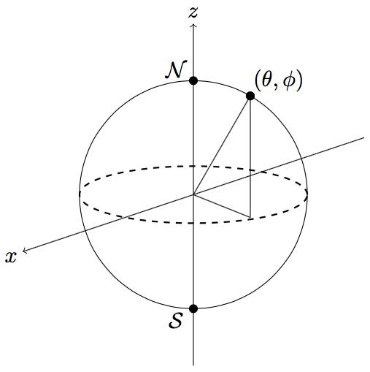
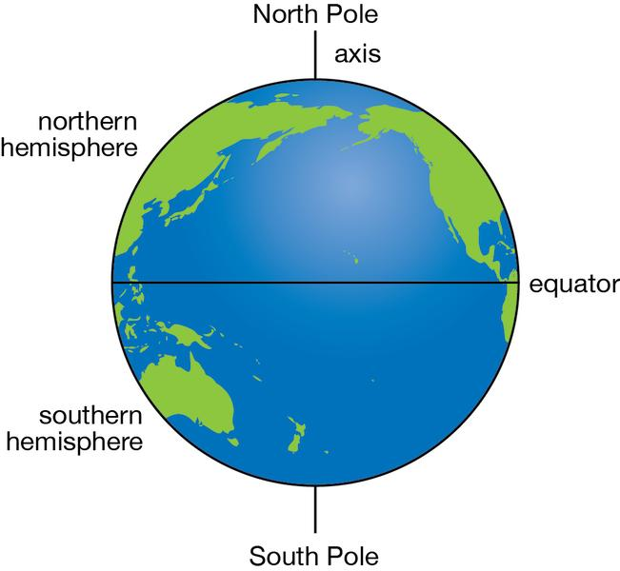
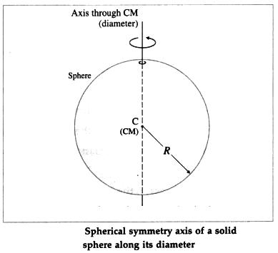

Definition
# Source: AI Source: Provided by: [Data Path: Persons Table -> ID Column: 1, Name_En Column: Motasem Essam] -> From: [ChatGPT] on [7/25/2026]
The sphere axis is a straight line passing through the center of a sphere. It may be chosen as a reference axis for describing the sphere's orientation, poles, equator, and rotational symmetry.
For a perfect sphere, every line passing through its center is an axis of rotational symmetry. Rotating the sphere through any angle around any such axis leaves its geometric shape unchanged.
When discussing a rotating body such as Earth, the term axis usually refers specifically to its axis of rotation.

Simple Definition
# Source: AI Source: Provided by: [Data Path: Persons Table -> ID Column: 1, Name_En Column: Motasem Essam] -> From: [ChatGPT] on [7/25/2026]
A sphere axis is an imaginary straight line through the center of a sphere, used to describe its symmetry or orientation.

Geometric Representation
# Source: AI Source: Provided by: [Data Path: Persons Table -> ID Column: 1, Name_En Column: Motasem Essam] -> From: [ChatGPT] on [7/25/2026]
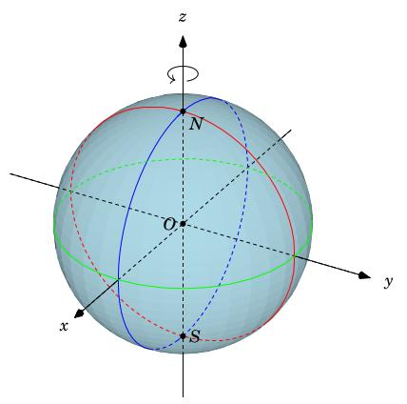
The main elements are:
- Sphere center ($O$): The point at the middle of the sphere.
- Axis line: The straight line passing through the center.
- Poles: The two points where a selected axis intersects the sphere's surface.
- Equatorial plane: The plane through the center perpendicular to the selected axis.
- Equator: The great circle formed by the intersection of the equatorial plane and the sphere's surface.
- Sphere radius ($R$): The distance from the center to any point on the sphere's surface.
The axis is an infinite line in mathematical geometry. The portion of that line inside the sphere is a diameter.

Examples of Sphere Axis

Axis of Symmetry
# Source: AI Source: Provided by: [Data Path: Persons Table -> ID Column: 1, Name_En Column: Motasem Essam] -> From: [ChatGPT] on [7/25/2026]
Any line through the center of a perfect sphere is an axis of rotational symmetry. The sphere looks unchanged after rotation around it.
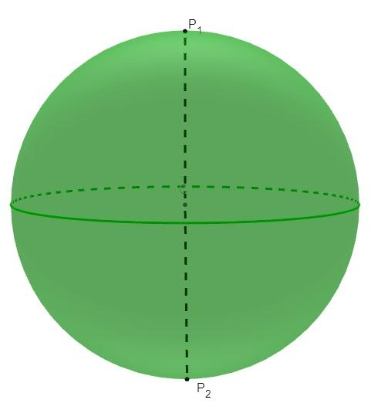

Axis of Rotation
# Source: AI Source: Provided by: [Data Path: Persons Table -> ID Column: 1, Name_En Column: Motasem Essam] -> From: [ChatGPT] on [7/25/2026]
The line around which a sphere or spherical body rotates. For Earth, this axis passes approximately through the geographic North and South Poles.
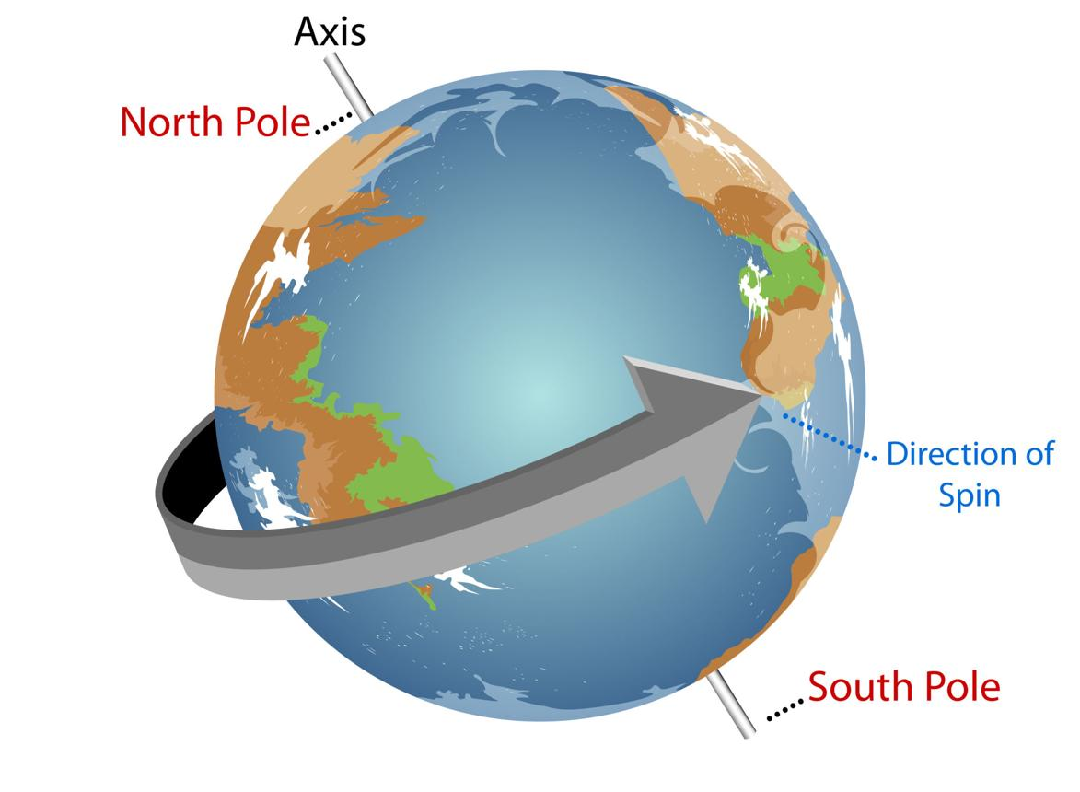

Polar Axis
# Source: AI Source: Provided by: [Data Path: Persons Table -> ID Column: 1, Name_En Column: Motasem Essam] -> From: [ChatGPT] on [7/25/2026]
A selected axis joining the two poles. It establishes the orientation used to define the equator and polar diameter.
Terminology note: For a perfect sphere, these axes can coincide when the same line is selected. They describe different roles, not necessarily different geometric lines.
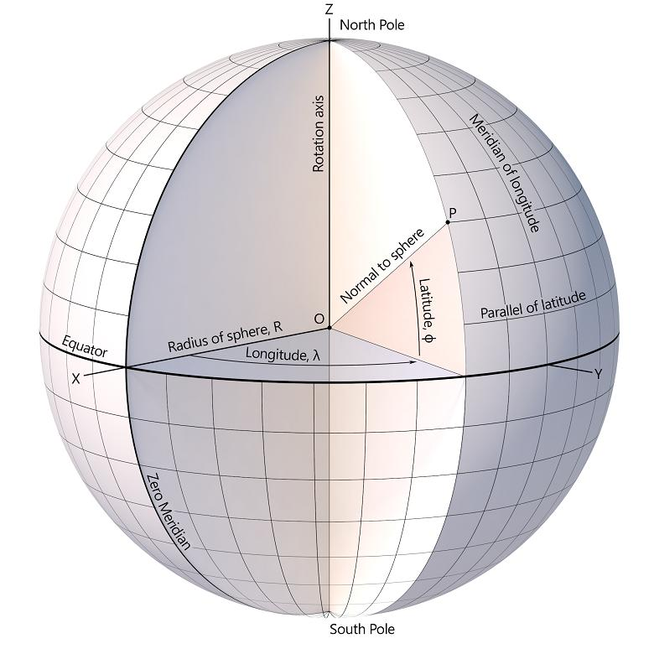

Key Characteristics
# Source: AI Source: Provided by: [Data Path: Persons Table -> ID Column: 1, Name_En Column: Motasem Essam] -> From: [ChatGPT] on [7/25/2026]
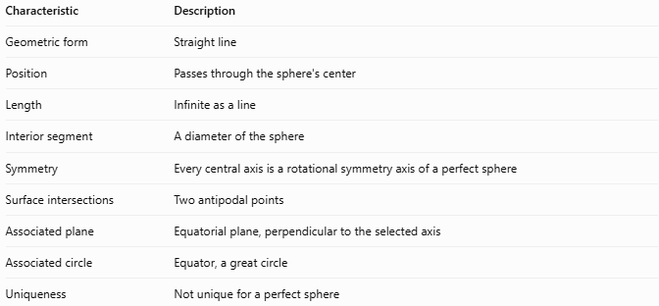
Characteristic | Description
Geometric form | Straight line
Position | Passes through the sphere's center
Length | Infinite as a line
Interior segment | A diameter of the sphere
Symmetry | Every central axis is a rotational symmetry axis of a perfect sphere
Surface intersections | Two antipodal points
Associated plane | Equatorial plane, perpendicular to the selected axis
Associated circle | Equator, a great circle
Uniqueness | Not unique for a perfect sphere

Mathematical Relationships
# Source: AI Source: Provided by: [Data Path: Persons Table -> ID Column: 1, Name_En Column: Motasem Essam] -> From: [ChatGPT] on [7/25/2026]
Let $O$ be the center and $R$ the radius of a sphere.

Axis and diameter
# Source: AI Source: Provided by: [Data Path: Persons Table -> ID Column: 1, Name_En Column: Motasem Essam] -> From: [ChatGPT] on [7/25/2026]
The diameter segment along the selected axis has length:
$$\boxed{D=2R}$$

Distance from the center to either pole
# Source: AI Source: Provided by: [Data Path: Persons Table -> ID Column: 1, Name_En Column: Motasem Essam] -> From: [ChatGPT] on [7/25/2026]
$$\boxed{OP=R}$$
Here, $P$ is either point where the selected axis meets the sphere's surface.

Perpendicular relationship to the equatorial plane
# Source: AI Source: Provided by: [Data Path: Persons Table -> ID Column: 1, Name_En Column: Motasem Essam] -> From: [ChatGPT] on [7/25/2026]
If $l$ is the selected axis and $Π_{e}$ is the equatorial plane:
$$\boxed{l⊥Π_{e}}$$
The axis intersects the equatorial plane at the sphere's center.

Worked Examples
# Source: AI Source: Provided by: [Data Path: Persons Table -> ID Column: 1, Name_En Column: Motasem Essam] -> From: [ChatGPT] on [7/25/2026]
Example 1 — Calculate the Diameter Along the Axis
Given: Sphere radius $R=6\text{ cm}$.
$$D=2R=2\left(6\right)$$
$$\boxed{D=12\text{ cm}}$$
Answer: The diameter segment along the axis is $12\text{ cm}$.
Example 2 — Identify the Equatorial Plane
A sphere has a vertical axis through its center.
Question: How is the equatorial plane oriented?
Answer: It passes through the center and is perpendicular to the vertical axis. Its intersection with the sphere's surface is the equator, a great circle.
Example 3 — Count the Axes of Symmetry
Question: How many axes of rotational symmetry does a perfect sphere have?
Answer: Infinitely many. Every line passing through its center is an axis of rotational symmetry.

Sphere Axis vs. Related Concepts
# Source: AI Source: Provided by: [Data Path: Persons Table -> ID Column: 1, Name_En Column: Motasem Essam] -> From: [ChatGPT] on [7/25/2026]
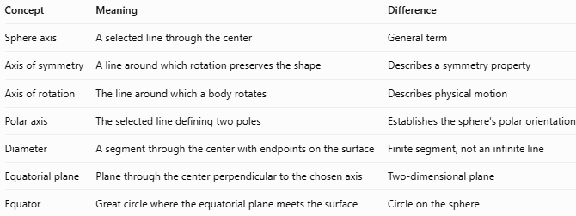
Concept | Meaning | Difference
Sphere axis | A selected line through the center | General term
Axis of symmetry | A line around which rotation preserves the shape | Describes a symmetry property
Axis of rotation | The line around which a body rotates | Describes physical motion
Polar axis | The selected line defining two poles | Establishes the sphere's polar orientation
Diameter | A segment through the center with endpoints on the surface | Finite segment, not an infinite line
Equatorial plane | Plane through the center perpendicular to the chosen axis | Two-dimensional plane
Equator | Great circle where the equatorial plane meets the surface | Circle on the sphere

Applications
# Source: AI Source: Provided by: [Data Path: Persons Table -> ID Column: 1, Name_En Column: Motasem Essam] -> From: [ChatGPT] on [7/25/2026]
- Geometry: Understanding rotational symmetry and the relationship between lines, planes, and spheres.
- Astronomy: Describing the orientation and rotation of planets and stars.
- Geography: Establishing the geographic poles, equator, and latitude reference.
- Engineering: Defining reference axes for spherical parts and three-dimensional models.
- Physics: Describing angular velocity and rotational motion of spherical bodies.

Key Points
# Source: AI Source: Provided by: [Data Path: Persons Table -> ID Column: 1, Name_En Column: Motasem Essam] -> From: [ChatGPT] on [7/25/2026]
- A sphere axis passes through the sphere's center.
- A perfect sphere has infinitely many axes of rotational symmetry.
- The diameter is the finite segment of an axis inside the sphere, between its surface intersections.
- A selected polar axis determines the equatorial plane and equator.
- The axis of rotation is a physical concept, while an axis of symmetry is a geometric concept.
- For a perfect sphere, the choice of axis does not change the sphere's shape.

Conclusion
# Source: AI Source: Provided by: [Data Path: Persons Table -> ID Column: 1, Name_En Column: Motasem Essam] -> From: [ChatGPT] on [7/25/2026]
The sphere axis is a central reference line used to describe the symmetry, orientation, and rotation of a sphere. Although a perfect sphere has infinitely many possible symmetry axes, selecting one establishes its poles, equatorial plane, and equator.

